EXPERIMENT – 3 ROLL NO:240701251
NAME:KAYALVIZHI R
SURVEY REPORT ON EMERGING TRENDS IN LOW-CODE APPLICATION DEVELOPMENT
Application Selected
Application Name: Event Registration & Participant Management
Platform: Zoho Creator
Form Name: Event_Registration_Form
Report Name: Event_Registration_Report

1. AIM
To study the emerging trends in low-code application development, compare traditional application development with low-code development, analyze the benefits and challenges of low-code platforms, and compare existing low-code application development platforms.

2. TRADITIONAL APPLICATION DEVELOPMENT VS EMERGING TRENDS IN LOW-CODE APPLICATION DEVELOPMENT
Traditional Application Development
Traditional application development requires developers to write code manually for different components such as the user interface, application logic, database operations and workflows. It generally requires programming knowledge and can take more development time.
Low-Code Application Development
Low-code application development uses visual development tools, drag-and-drop components, pre-built controls and configuration-based development. It reduces the amount of manual coding required and helps developers create applications more quickly.
Comparison
Traditional Application Development | Low-Code Application Development
Requires extensive programming | Requires minimal coding
Components are developed mainly through code | Components can be created using visual tools
Development can take more time | Faster application development
Requires strong programming knowledge | Can be used by developers and citizen developers
UI and application logic are manually developed | Provides pre-built components
Testing and maintenance require development effort | Built-in features can simplify development
Highly customizable | Customization depends on the platform
Application Used in This Experiment
The selected application is Event Registration & Participant Management. It is implemented using Zoho Creator to collect participant details, contact information, institution details, event preferences and scheduling information.

3. BENEFITS AND CHALLENGES IN LOW-CODE DEVELOPMENT
Benefits
- Faster Development – Applications can be developed quickly using visual components.
- Less Coding – The amount of manual programming is reduced.
- Easy Form Creation – Forms can be created using pre-built field types.
- Rapid Prototyping – Applications can be designed and tested quickly.
- Easy Modification – Fields and application components can be modified easily.
- Workflow Support – Workflows can be configured within the platform.
- User Friendly – Visual interfaces make application development easier.
Challenges
- Limited Customization – Some complex requirements may not be easily implemented.
- Platform Dependency – Applications may depend heavily on the selected low-code platform.
- Complex Applications – Advanced applications may still require programming.
- Integration Issues – Connecting complex external systems may require additional configuration or coding.
- Security Considerations – Application and data security must be properly managed.
- Migration Difficulty – Moving an application from one low-code platform to another may require additional effort.

4. COMPARISON OF EXISTING LOW-CODE PLATFORMS
Feature | Zoho Creator | Microsoft Power Apps | OutSystems | Mendix
Development Method | Visual / Low-Code | Visual / Low-Code | Low-Code | Low-Code
Form Creation | Yes | Yes | Yes | Yes
Workflow Automation | Yes | Yes | Yes | Yes
Database Support | Yes | Yes | Yes | Yes
Visual Development | Yes | Yes | Yes | Yes
Rapid Development | Yes | Yes | Yes | Yes
Customization | Moderate to High | High | High | High
Suitable For | Business applications and forms | Business and enterprise applications | Enterprise applications | Enterprise applications

5. IMPLEMENTATION AND SCREENSHOTS
5.1 Creating the Event Registration Form
A form named Event_Registration_Form was created in Zoho Creator. The form uses the Basic Fields provided in the application specification.
The fields include:
- Name
- Email
- Address
- Phone
- Single Line
- Multi Line
- Number
- Date
- Time
- Drop Down
- Radio
- Multi Select
- Checkbox
Screenshot – Event Registration Form Builder
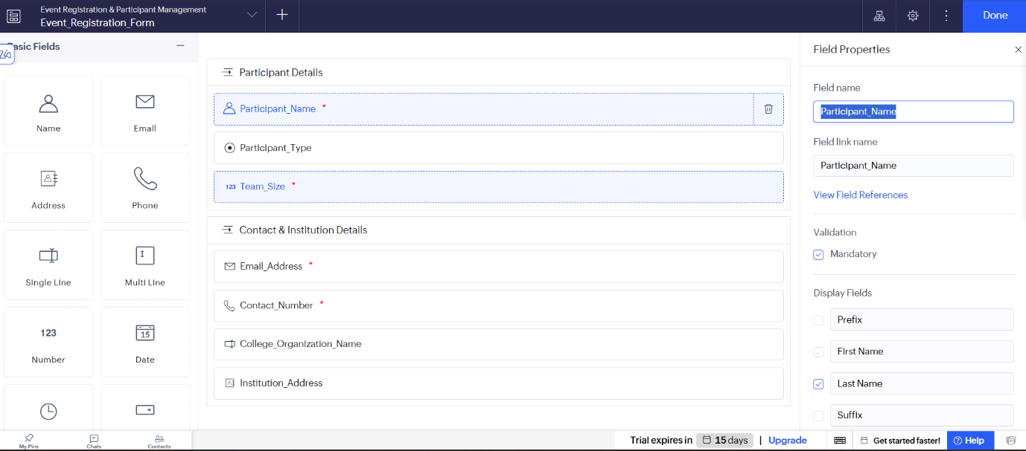

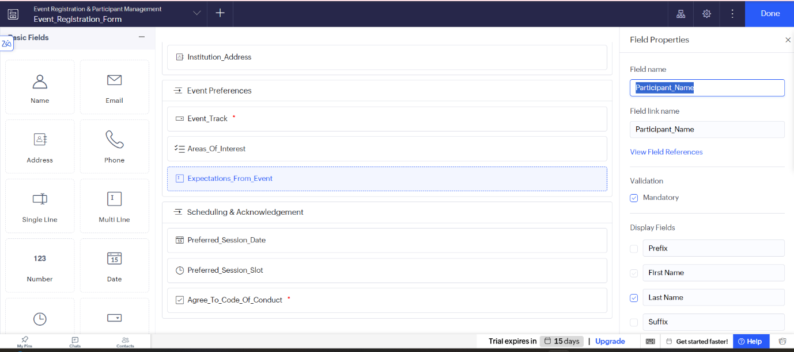
5.2 Form Sections
The form is divided into four sections:
Section A – Participant Details
- Participant Name
- Participant Type
- Team Size
Section B – Contact & Institution Details
- Email Address
- Contact Number
- College/Organization Name
- Institution Address
Section C – Event Preferences
- Event Track
- Areas of Interest
- Expectations From Event
Section D – Scheduling & Acknowledgement
- Preferred Session Date
- Preferred Session Slot
- Code of Conduct Checkbox

5.3 Validation Rules
Validation rules are configured for the form. Mandatory fields include Participant Name, Email, Phone, Participant Type, Event Track and Code of Conduct.
The Team Size field is restricted to a value between 1 and 6. Email and phone fields use appropriate validation.

5.4 Live Preview
After completing the form, the application is previewed to verify the layout and functionality of all fields.
Screenshot – Live Preview of Event Registration Form
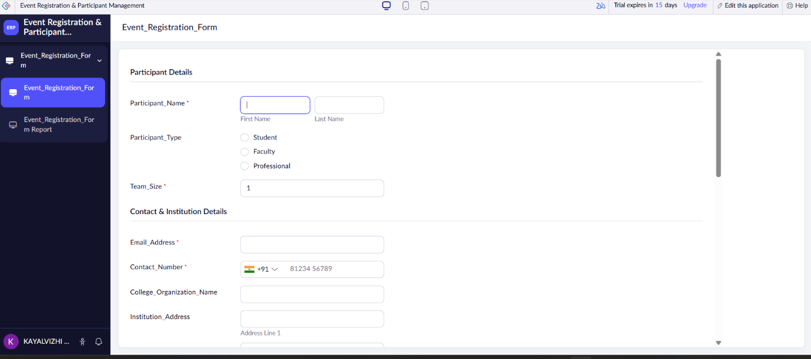

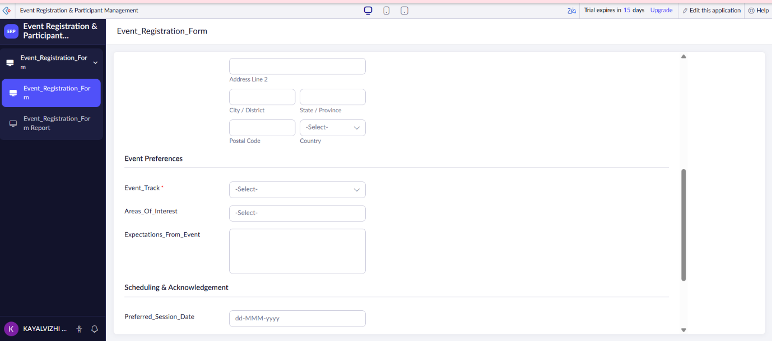

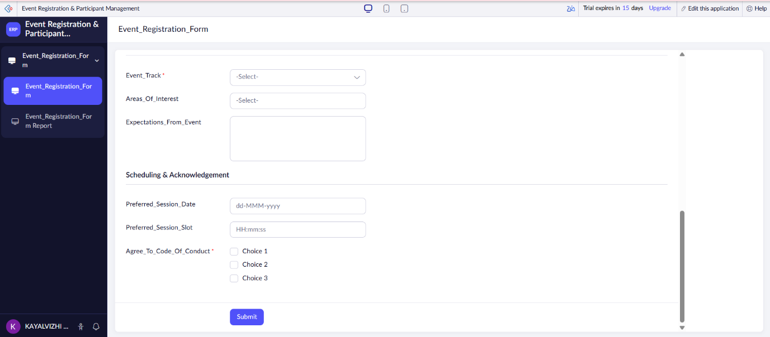

5.5 Sample Records and Report
Three sample participant records are submitted through the Event Registration Form. The submitted information is displayed in the Event_Registration_Report.
Screenshot – Event Registration Report with Three Sample Records
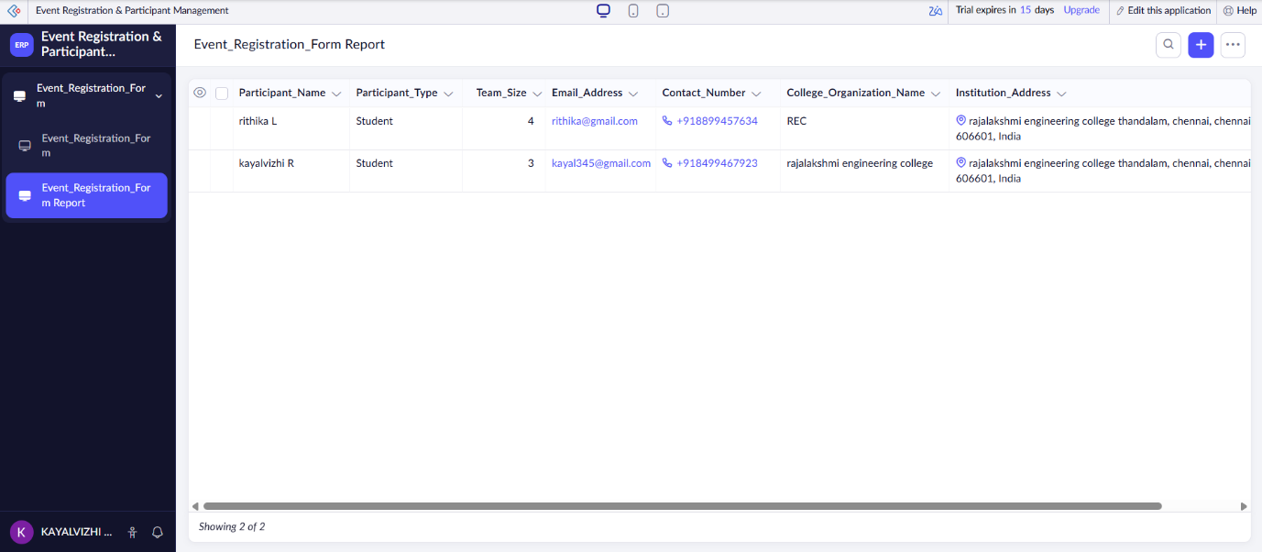
6. RESULT
Thus, the survey on emerging trends in low-code application development was successfully completed. The Event Registration & Participant Management application was implemented using Zoho Creator. The experiment demonstrated the use of low-code development for creating forms, applying validations, collecting participant information and managing submitted records through a report

